Pick and Place Robot

Task:

We are assigning the task that over the floor there are 3 balls (Blue, Red & Green). The floor is marked with the grid which help Robot to move.

Specification of Robot:

Our robot is autonomous which will perform all the task by its own once placed in perfect orientation. It will scan all the area through Pi-cam over it (by following grid pattern) and find Blue, Green & Red balls. When it finds the ball, it picks up the ball through gripper and placed it in the respective compartment of the bot.

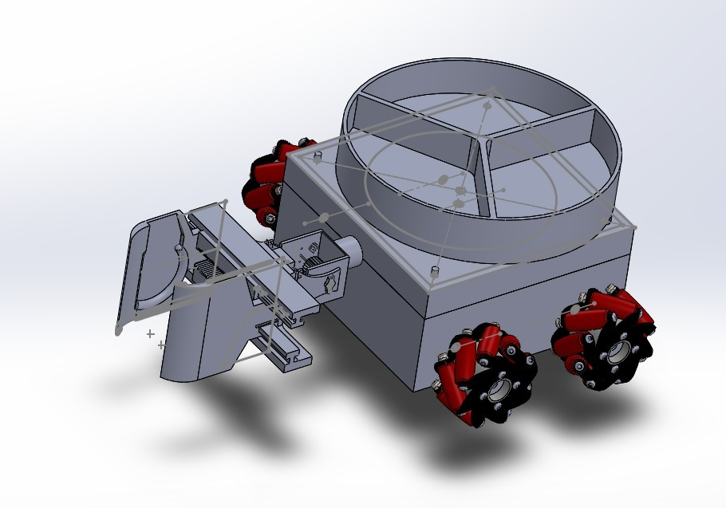

Functionalities of the Robot:

* Electrical division:
* The electronic deals with the movement and logic of the Robot. It comprises of the Raspberry pi which will is the mind of the Robot and give command to Arduino after receiving the input from Picam.
* The basic idea is that raspberry pi will run the python code and do the image processing using OpenCV code which enables the Robot to detect the shape and color that results to the string. String received by Arduino which decide the functioning of Robot.
* If no ball detected, then the Bot will move over the grid and scan all area.
* If ball is detected, an string is received by Arduino from pyhton through pyserial which perform following function
* It will stop for 1 min (can be change according to physical constraint), compartment will rotate in either direction according to the color of the ball & gripper will hold the ball rotate about 100 degree to place the ball in compartment.
* After picking up the ball the Robot continue to follow the grid pattern.
* There are 3 IR sensor which gives the input to logic for movement of the bot.
* Here’s are the link of the Arduino code and python code which communicate through pyserial library.

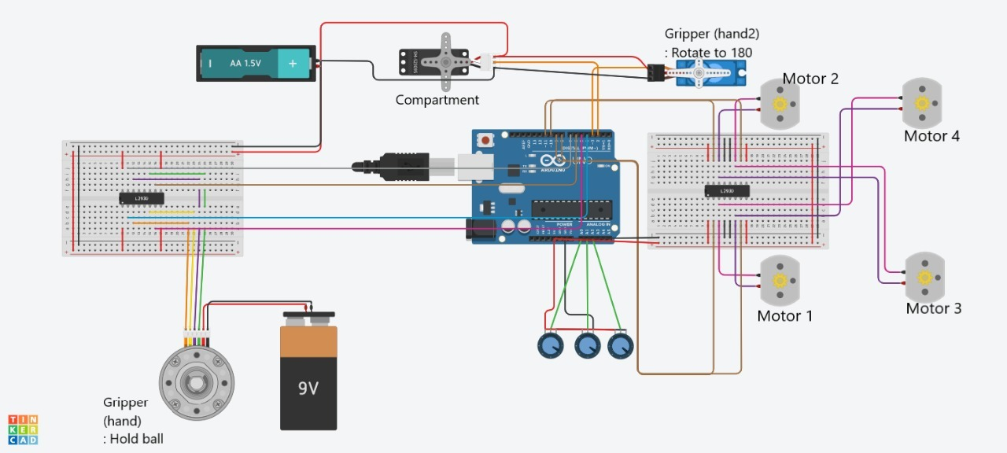

**Note –** There is assumption assumed that the Robot is placed at the Right most backward corner of the Grid Pattern with all 3 IR sensors over the black line.

Tinker Cad Arduino Code :-

https://www.tinkercad.com/things/354Y1Ip9LxX-latest-bot-code/editel

All Code :-

[ShellVoyageMetal (codecollab.io)](https://codecollab.io/@proj/ShellVoyageMetal)

* Mechanical Division:

The base of our robot is 15*15 cm^2.

The different main parts used in it are:

* Mecanum wheels
* Rack and pinion
* Jaws
* Cylindrical compartment
* Rippets…etc.

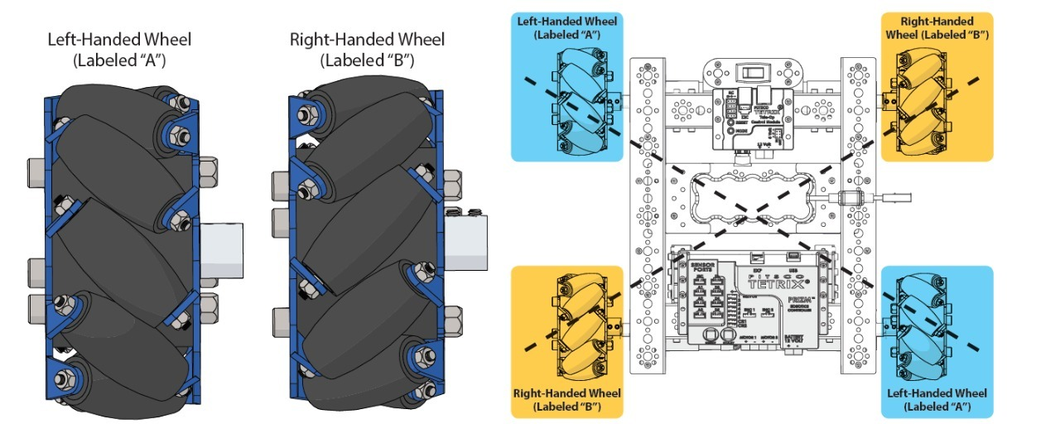

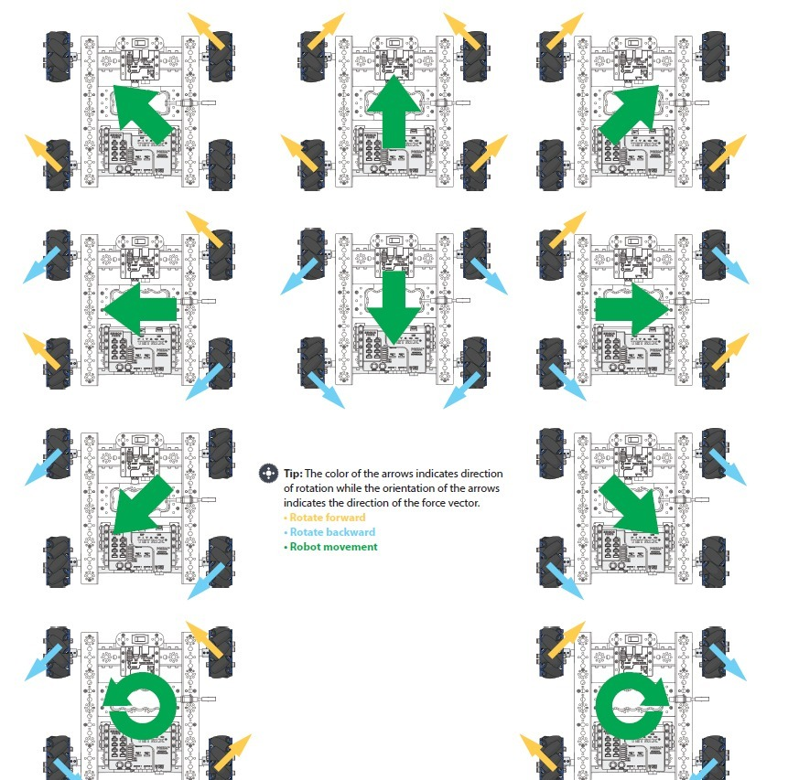

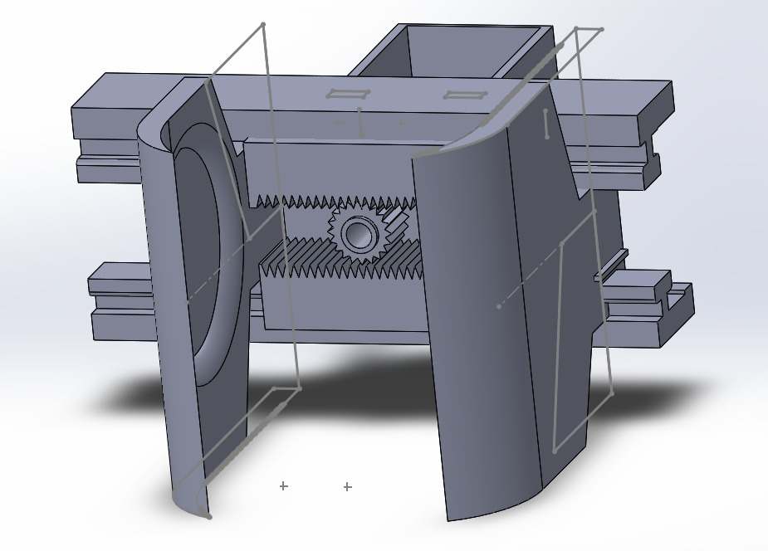

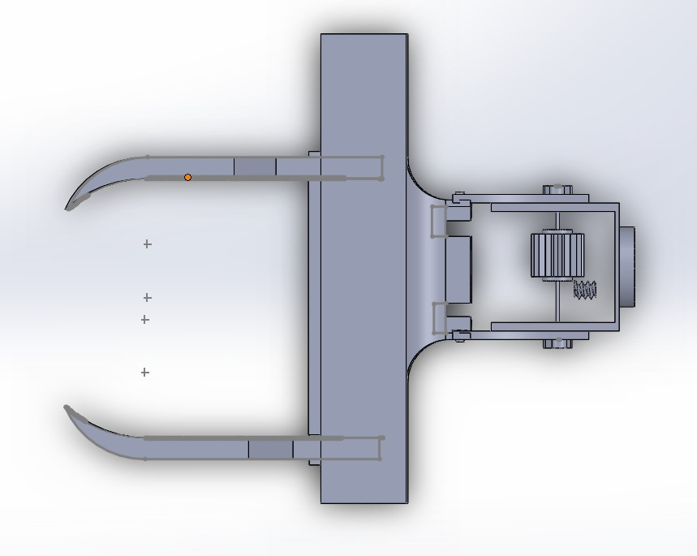

GRIPPER’S MECHANISM: - The gripper consists of two motor drivers. First one is to capture

and release the ball, while the second one is for placing the ball into the compartment.

The gripper will pick the ball of approx. diameter of 7.8cm from slightly below its center. So that the ball get better pick easily without dropping the ball.

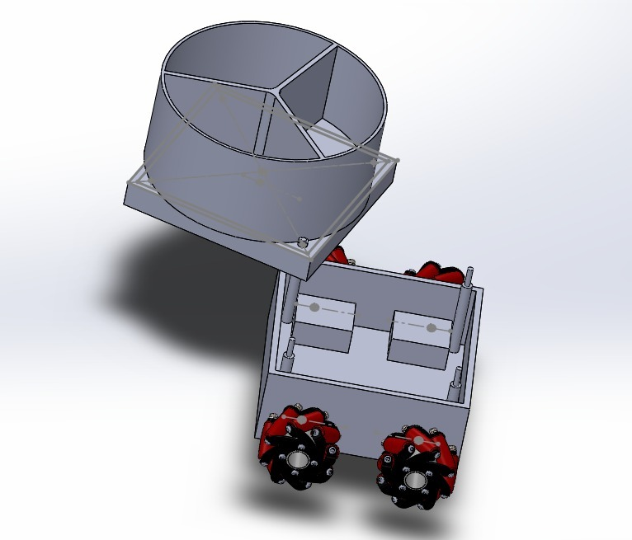

About COMPARTMENT specs: -- The compartment is cylindrical and having the equal space at an angle of 120 deg for the ball to fit into. The compartment is having a rotor at the bottom of the base which will get rotated after the ball get dropped into it. There is a disk consist of the small rings which is used to reduce the friction sharply. Inside the base there is space for other stuffs to fit into like battery, Arduino, motors driver…etc.

Height of the cylindrical compartment from base is 68mm.

THE DOF: -

* GRIPPPER (1)
* WHEELS (3)
* COMPARTMENT COVER (1)

Challenges:

* Electrical –
* Communication between Arduino and python code is the challenge.
* Use Raspberry Pi for automatization of Robot. Both the code (Arduino & Python) and will run over it and communicate through pyserial.
* MECHANICAL –

1. Cad assembly and fixation among parts.
2. MAKING PARTS WITH SMALL DIMENSIONS
3. EASE IN ROTATION.

Solutions:

* Electrical –

1. Pyserial is the library with act as a medium between Arduino and python code.
2. Virtual Box help as a raspberry pi where all code can run and compile as an autonomous Robot.

* MECHANICAL :--

Redrawing and taking again everything with proper dimensions

And MENTOR guidance helped us a lot.

Team:

* Dhruv
* Hemant
* Srushti
* Uday
* Aditya

Mentor:

* Aditya Sir
* Bhavna Mam